- Mathematical Models of Noise:

- Gaussian Noise
Gaussian noise is an additive noise where the noise value added to each pixel follows a Normal (Gaussian) distribution. It typically models electronic circuit noise and sensor amplifier noise caused by thermal heat.
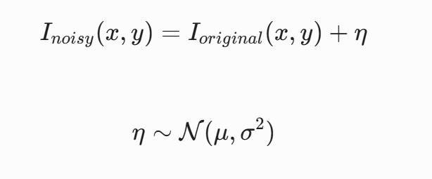
$$I_{noisy\left(x,y\right)}= I_{original\left(x,y\right)}+ eta, eta \sim N\left(mu, sigma^{2}\right)$$

- Salt-and-Pepper Noise
Also known as impulse noise, this represents sudden, sharp disturbances. It is caused by memory cell faults, Analog-to-Digital converter errors, or faulty sensor pixels. Pixels randomly take on either the absolute minimum value (pepper) or maximum value (salt), completely overwriting the original structural data.
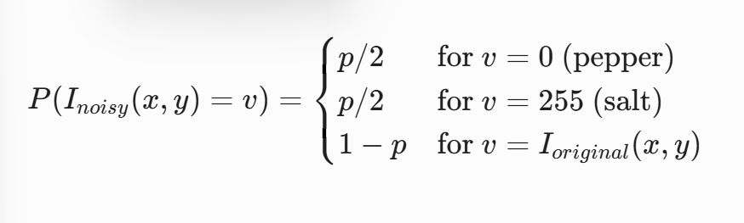

- Poisson Noise
Poisson noise (shot noise) is signal-dependent and models the quantum nature of light. It arises because photon arrival at an image sensor is a discrete statistical process governed by a Poisson distribution. The noise variance is equal to the expected local signal intensity.

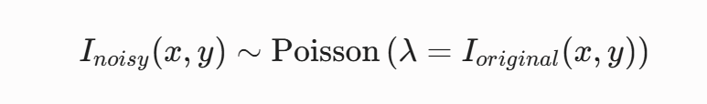

- Denoising Mechanism & Capability Matrix:

- Mean (Box) Filter
- Mechanism: Replaces a target pixel with the uniform arithmetic mean of its spatial neighbourhood.
- Performance: It performs moderately against Gaussian noise by lowering the variance, but it fundamentally acts as a low-pass filter. This completely blurs crisp edges and structural details. It performs poorly against Salt-and-Pepper noise because the extreme values (0 or 255) are included in the average, dragging the output intensity away from the true underlying signal.

- Median Filter
- Mechanism: Sorts the pixels in a localized window and replaces the center pixel with the middle value (median).
- Performance: It is the gold standard for Salt-and-Pepper noise. Because impulse noise spikes represent outliers (extreme minima/maxima), they naturally fall at the absolute ends of the sorted list and are eliminated by the median selection. However, it handles Gaussian or Poisson noise poorly, often creating flat, artificial "blocky" patches (staircase effect).

- Gaussian Filter
- Mechanism: Convolves the image with a spatial Gaussian kernel, weighting closer pixels higher than distant ones.
- Performance: It is highly effective for Gaussian noise because convolving a Gaussian distribution with another Gaussian distribution maintains mathematical consistency while smoothing out zero-mean variations. Like the mean filter, it is isotropic and fails to recognize edges, causing structural blurring along boundaries.

- Bilateral Filter
- Mechanism: An edge-preserving, non-linear filter that extends the Gaussian filter by incorporating a photometric (range) kernel alongside the spatial kernel.
- Performance: It is excellent for Gaussian and Poisson noise while preserving sharp boundaries. A neighbour pixel only heavily influences the target pixel if it is both spatially close and visually similar in intensity. If a neighbor is across a sharp edge, the radiometric difference is high, dropping its weight to near zero and preserving the edge.

- Non-Local Means (NLM) Filter
- Mechanism: Instead of averaging nearby individual pixels, NLM targets structural redundancy. It compares a small patch surrounding the target pixel to other patches across an extensive search window. The target pixel is replaced by a weighted average of pixels whose surrounding patches look highly similar to the target patch.
- Performance: It delivers the highest structural restoration performance (SSIM) against Gaussian and Poisson noise. It preserves fine, repetitive textures and patterns beautifully because it can draw clean data from identical textures found elsewhere in the frame.

- Summary Matrix:

Filter | Best Match For | Fails At / Key Disadvantage | Edge Retention
Mean Filter | Uniform structural smoothing | Salt-and-Pepper noise, introduces heavy blur | Poor
Median Filter | Salt-and-Pepper Noise | Gaussian/Poisson noise, creates patchy artifacts | Strong
Gaussian Filter | Gaussian Noise | Blurs fine detail and high-frequency edges | Poor
Bilateral Filter | Gaussian & Poisson Noise | High computational overhead, fails on Salt-and-Pepper | Excellent
Non-Local Means | Complex textures with Gaussian/Poisson | Extremely slow computation time | Superior

